

The Gaming Room

CS 230 Project Software Design
Version 1.0

Table of Contents

1. CS 230 Project Software Design Template 1
Table of Contents 2
Document Revision History 2
Executive Summary 3
Requirements 3
Design Constraints 3
System Architecture View 3
Domain Model 3
Evaluation 4
Recommendations 5
2. Operating Platform: Ubuntu 23 5
3. Operating Systems Architectures: <Describe the details of the chosen operating platform architectures.> 5
4. Storage Management: Data stored as files and in MySQL 5
5. Memory Management: Server-side and client-side management 5
6. Distributed Systems and Networks: Server sided management 5
7. Security: Anonymity of players 5

Document Revision History

Version | Date | Author | Comments
1.0 | 01/28/24 | Catherine Denis | First draft of requirements

Executive Summary

The Gaming Room is looking to develop a web-based environment for their Android game application “Draw It or Lose It”. This will account for multiple unique users, teams, and games running at once. Each instance of the game must be unique due to memory restrictions.

Requirements

- Only one instance of the game, team, or player can exist at a time.
- Game and team names must be unique.
- Each game can have multiple teams involved.
- Each team will have multiple players assigned to it.
- High loading speed of assets

Design Constraints

Server-side capacity for number of games and players able to play at once
- This will limit the number of games and players per game
  - Limiting the number of players and teams per game will allow more games at a time to be played
System capacity (RAM, Virtual Memory, Bandwidth)
- Depending on the demands the game requests of the system, the game play can slow down
  - Images must be able to load fast enough so that it doesn't interfere with gameplay
Software
- Depending on the software used to create the game, elements of the software may limit what can be delivered to the user
  - Some tools export to HTML5 but cannot work with macOS and iOS due to bugs around SharedArrayBuffer and WebGL 2.0 (e.g., Godot)

System Architecture View

Depending on the capacity of the machine and servers used, the number of teams and players per team will need to have a limit in order not to overload the machines or servers used. Bandwidth will determine the asset loading time, which will impact the users depending on how and when images are rendered into a game. The software involved, may require users to download the software separately if it isn't already packaged with the operating system or browser used by a player.

Domain Model

In this model, the singleton and iterator design patterns are implemented to accomplish the uniqueness of the different portions of the system involved. The singleton pattern ensures that one game service instance is running at a time. The iterator pattern ensures that each game, team and player added are unique to their respected relationships. Game, Team, and Player all inherit from the Entity class in order to simplify the implementation of attributes and methods they all have in common.

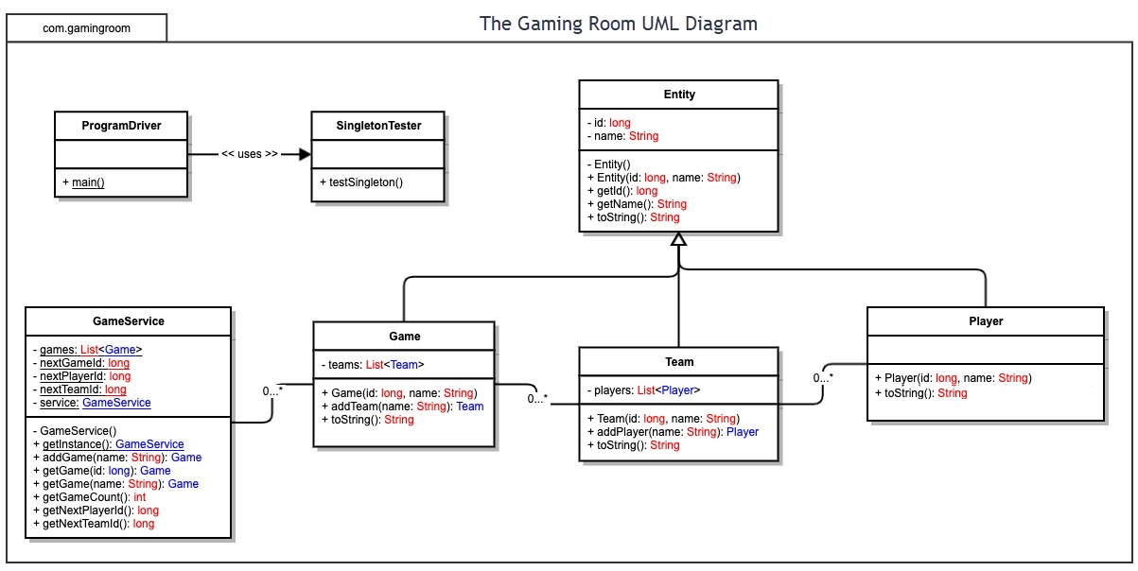

Evaluation

Development Requirements | Mac | Linux | Windows | Mobile Devices
Server Side | Server side the images need to load and answers need to be compared with the player's guesses.  Some options for tools here are  MySQL, PHP, React, GitHub | Server side the images need to load and answers need to be compared with the player's guesses. Some options for tools here are Apache, MySQL, GitHub | Server side the images need to load and answers need to be compared with the player's guesses. Some options for tools here are  MySQL, MSSQL, PHP, React, GitHub | Server side the images need to load and answers need to be compared with the player's guesses. Some options for tools here are  MySQL, PHP, React, GitHub
Client Side | A small percentage of players will be on a Mac. A Mac is the most costly of all these options. | A small percentage of players will be using Linux OS. Costs are next to 0 for getting any current device to use Linux. | Largest percentage of potential players may own a Windows device. Less costly than a Mac. Most commonly used version at this moment is likely Windows 10. | A large amount of players may be using a mobile device for gaming. Device costs can be less than a typical laptop or desktop device. Typically, downloading apps vs playing on mobile websites due to the aspect ratio and limitations around system capacity (RAM, Virtual Memory)
Development Tools | The default browser is Safari. IDE options are XCode, Android Studio, NetBeans, are PyCharm | The default browser is  Firefox. IDE options are IntelliJ, Ecllipse, NetBeans, and PyCharm | The default browser is Edge. IDE options are Visual Studio, Android Studio, NetBeans, PyCharm, and IntelliJ | The default browser is Google Chrome and Safari. IDE options are Android Studio and XCode

If thousands of players are intended to be playing at a time, we would need enough memory to have a certain number of players playing together and games running on the server as well as storage. If the website already has this capability, there will be no need to add more to the server side to handle this. However, it would be an issue otherwise due to the limitations of the budget. The cheapest option that is also functional would have to be sought out. That could include adding memory and storage capabilities to the current server. The server and client communication would need to be at a high capacity due to the amount of clients needing to access the server. In order to comply to all options (i.e., web browser, desktop, and mobile) the development team will need to be able to replicate the application in various ways. Using a programming language that can be adapted to each platform would limit the need to write source code from scratch. Nevertheless, there will still be a need to adapt the source code to function with each platform.

To state some specifics in costs associated with the choices available: MSSQL has different pricing depending on needs. A standard server costs about $989 and enterprise around $15,123. GitHub has 3 tiers for standard performance and file storage. If any images or files are larger than 2GB, the free tier will not be sufficient. If advanced security is needed, there is an option for advanced security that costs $49/ month. To add an app to iTunes, it is required to use the Apple Developer Program to be able to distribute the app onto the store. This costs $99 per year.

Recommendations

- Operating Platform: Ubuntu 23 - Linux for server for Android and multiple other OS applications. Linux is free, able to apply to multiple business-case use, and adaptable to a variety of cloud platforms

- Operating Systems Architectures: 64 bit processor due to faster speeds and increased security. Expectation of user RAM averaging possibly around 8GB

- Storage Management: Images stored as files as webp type, locations and answers in database of choice (cloud, MySQL), use of CDNs to reduce file size as much as possible.

- Memory Management: Clustering and running games in parallel. Limiting number of players and teams per game.

- Distributed Systems and Networks: If there are any connectivity issues, player inputs would have difficulty registered. A way to handle this is to end a game short if the issue is server side. If the issue is client side, pass through the player's turns as usual to not interrupt game

- Security: Player anonymity would protect player data and limitations on players creating and participating in games limits overloading server.

